UEC26: Text for social media posts
Card 1:
Recently used NHS A&E or Urgent Treatment Centre services?
Take a moment to share your experience in the #UrgentandEmergencyCareSurvey and join thousands helping to make a difference to NHS care.
If selected, you’ll receive an invitation letter in the post soon.
Your valuable feedback will help us improve the quality of care for everyone.
Find out more about the survey: [INSERT TRUST PRESS RELEASE LINK FOR URGENT AND EMERGENCY CARE SURVEY IF AVAILABLE]
Further information on Section 251: Confidential patient information - Health Research Authority

#UrgentandEmergencyCareSurvey
Social media card: Take action
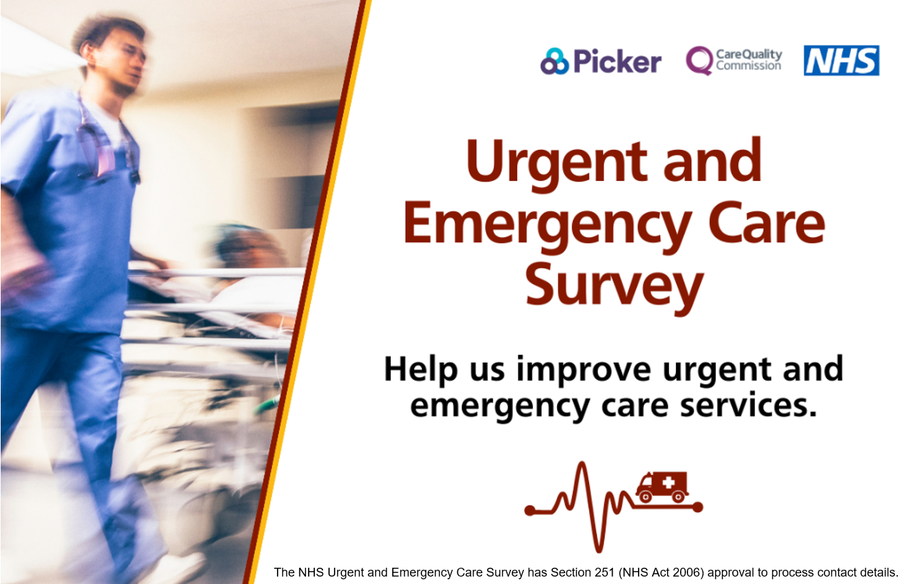
Card 2:
Over 40,000 voices helped shape NHS urgent care as part of the 2024 survey. Now, it’s your turn to make a difference. Listening to people who have used our services is the best way for us to improve.
If you’ve recently used NHS A&E or Urgent Treatment Centre services, you might be invited to take part in this year’s #UrgentandEmergencyCareSurvey.
Look out for a letter in the post and a text reminder too.
Find out more about the survey: [INSERT TRUST PRESS RELEASE LINK FOR URGENT AND EMERGENCY CARE SURVEY IF AVAILABLE]
Further information on Section 251: Confidential patient information - Health Research Authority

#UrgentandEmergencyCareSurvey
Social media card: Reminder One
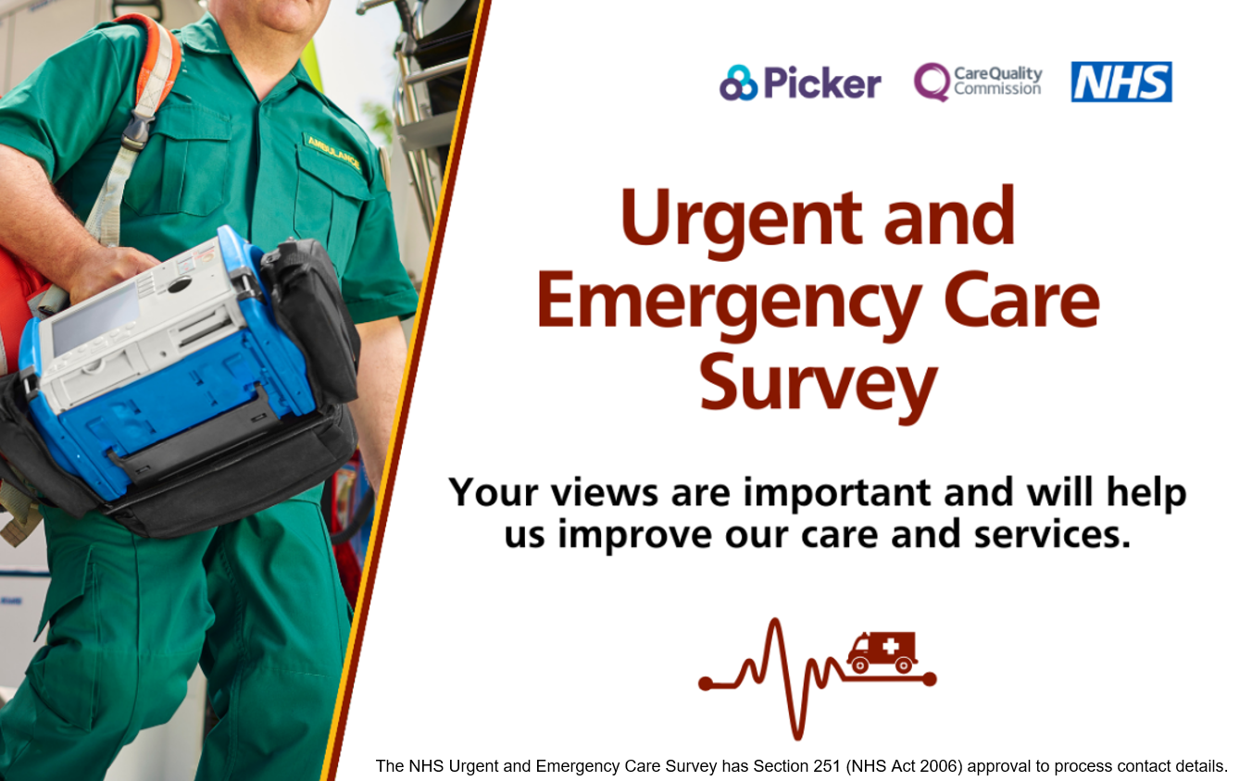

Card 3:
Every voice matters. Will you take a moment to make your voice heard and share your experience of urgent and emergency care?
If you’re selected to take part, you’ll receive an invitation in the post and a text message reminder with a survey link to share your experience.
Find out more about the survey: [INSERT TRUST PRESS RELEASE LINK FOR URGENT AND EMERGENCY CARE SURVEY IF AVAILABLE]
Further information on Section 251: Confidential patient information - Health Research Authority
#UrgentandEmergencyCareSurvey
Social media card: Reminder Two

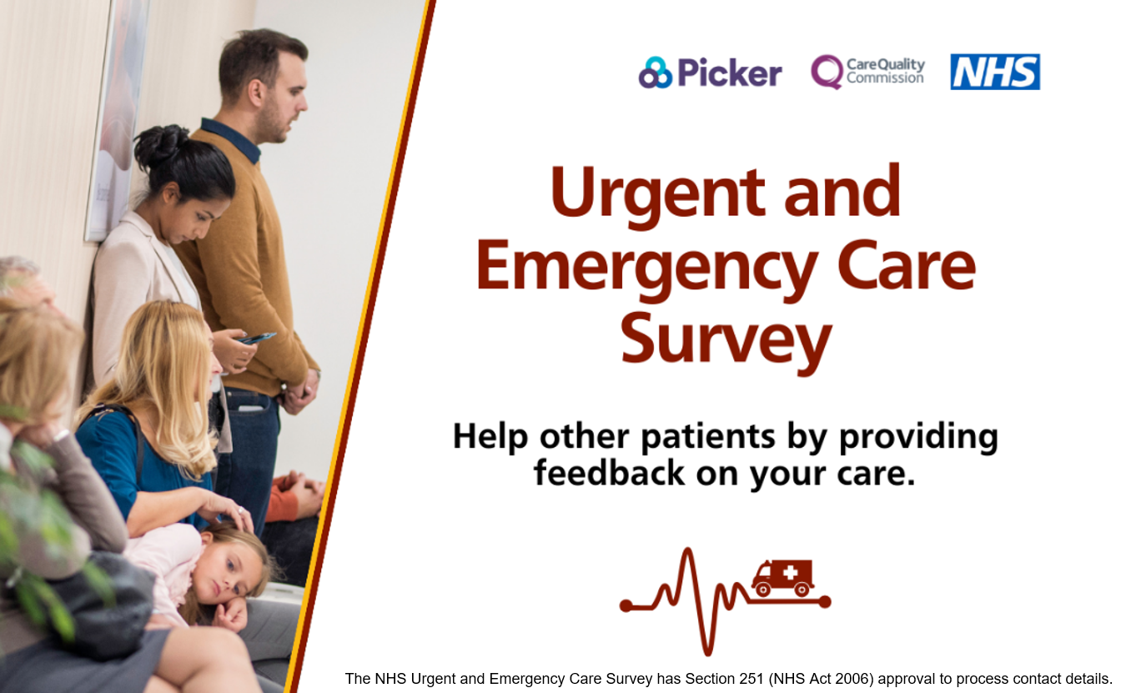

Card 4:
Recently used NHS A&E or Urgent Treatment Centre services?
Don’t miss this chance to give feedback on your care and treatment.
If selected, you’ll receive an invitation letter for the #UrgentandEmergencyCareSurvey in the post soon.
Find out more about the survey: [INSERT TRUST PRESS RELEASE LINK FOR URGENT AND EMERGENCY CARE SURVEY IF AVAILABLE]
Further information on Section 251: Confidential patient information - Health Research Authority
#UrgentandEmergencyCareSurvey
Social media card: Reminder Three
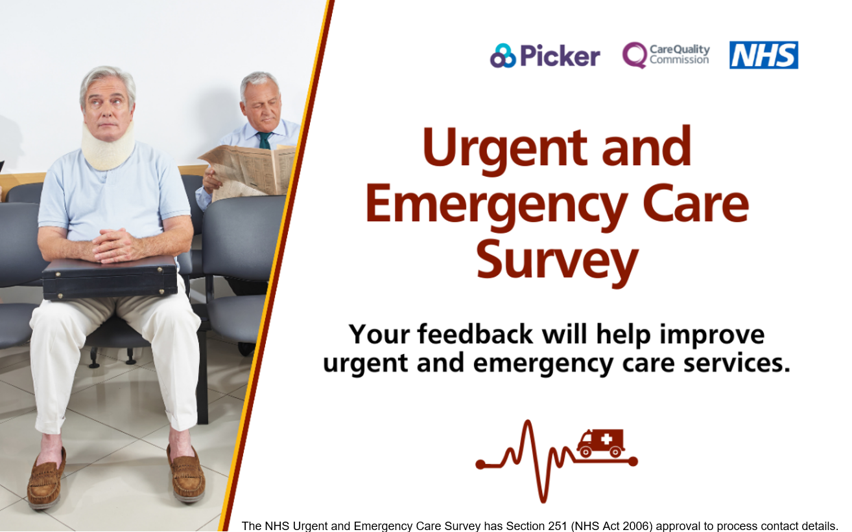

The NHS Urgent and Emergency Care Survey has Section 251 (NHS Act 2006) approval to process contact details.

